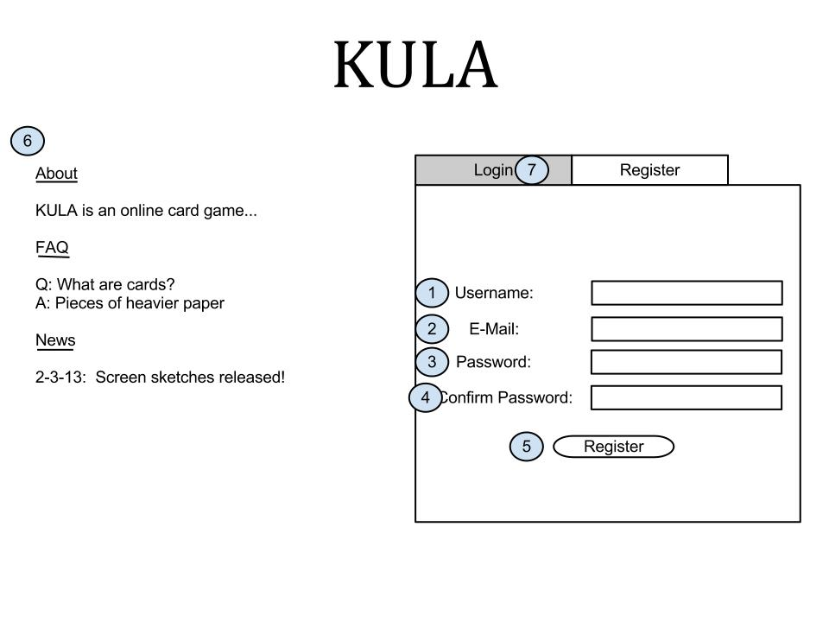The register screen appears when the user clicks the link on the home screen in order to register for an account and play games on our system. The account functions to distinguish players from each other in-game and chat.

Registration Screen - Trevor Lund

The screen itself functions as a fairly simple register screen, as we don’t need a lot of their information to allow them to play the game. There are fields for a username (1) and password (3) of course, and a field for an e-mail address (2) in case they forget their password or if there is a need to have a message sent out to them. Additionally, there is a password confirmation field (4) to reduce the amount of forgotten passwords. Links are in place to submit the registration form (5) and to navigate to the “Login Screen” (7) if the user already has an account. Finally there is the information panel (6), containing information about the game, FAQ, and updates or announcements about the game.